**AWS :**

**EC2 Image Builder**

Step 1: login to aws management console and navigate to EC2 image builder .

Step 2: EC2 image builder —-> image pipelines—-----> create image pipelines

Step 3: specify pipeline details:

name the pipeline ,enable “enhanced metadata collection” and select “manual” build schedule.then click on “next”

Step 4: choose recipe:

create a new recipe or choose existing one.here we create a new recipe.Select the image type - AMI then name the recipe .Select the source image as “Select managed images” and choose the “Amazon Linux” operating system.And image origin will be “Quick start(Amazon-managed)”and image name will be “ Amazon Linux 2 x86”.

Then choose the “use latest available OS version” as auto-versioning options.working directory path will be default.after that select the following build components: “amazon-corretto-11-headless”

“Aws-cli-version-2-linux”

Skip the Test components ,then click on “next”.

Step 5: Define Infrastructure configuration :

choose the configuration option as “create a new infrastructure configuration” . name the infrastructure and then create a new role.

Step 6: create a IAM role having policies:

EC2InstanceProfileForImageBuilder

EC2InstanceProfileForImageBuilderECRContainerBuilds

AmazonSSMManagedInstanceCore

And name the role as “EC2InstanceProfileForImageBuilder” ,it is default name for IAM role for ec2 image builder.

Step 7: Then move to ec2 image builder and then select the created iam role in infrastructure configurations.then select the instance type as “t2.micro” then click on “Next” .

Step 8 : Define distribution settings: select the configuration option as “create distribution settings using service defaults” .then click on “Next” .

Step 9 : Review: then review all the settings then click on “create Pipeline” .

Step 10: After clicking on create pipeline ,then check the image status ,it would be building .Now go to ec2 console ,you will see an ec2 instance created by ec2 instance builder.

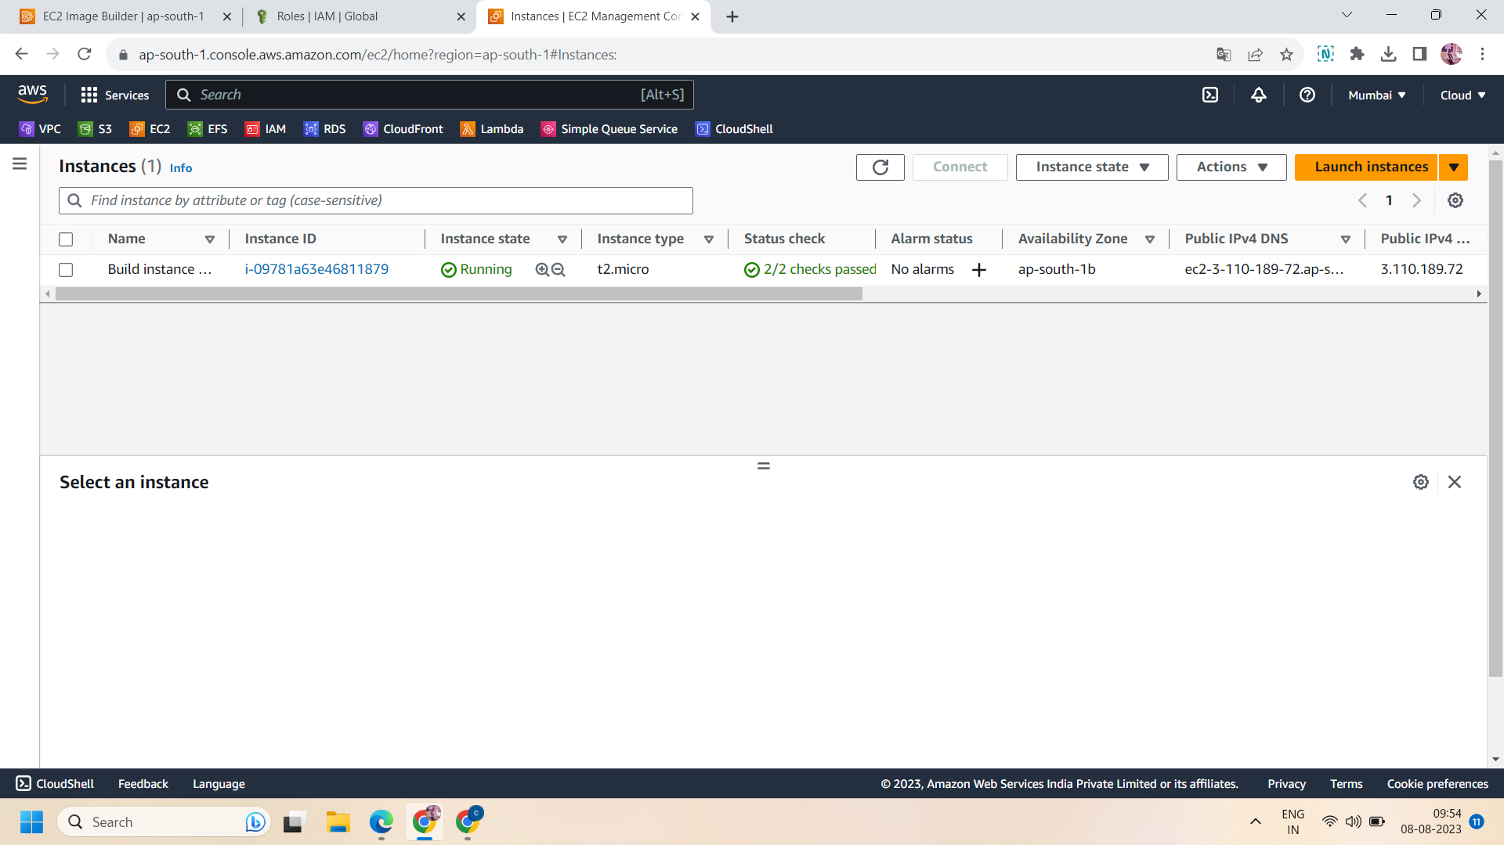

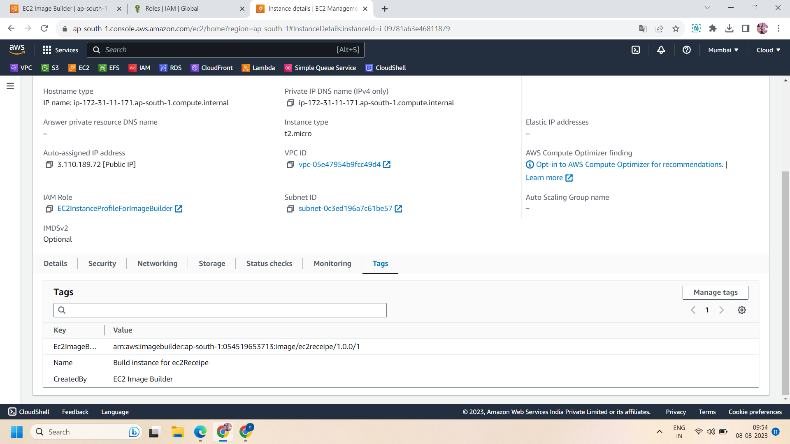

Step 11: when the status of image changes from building to testing then a new instance will be created by ec2 instance builder and the previous instance will be shut down.

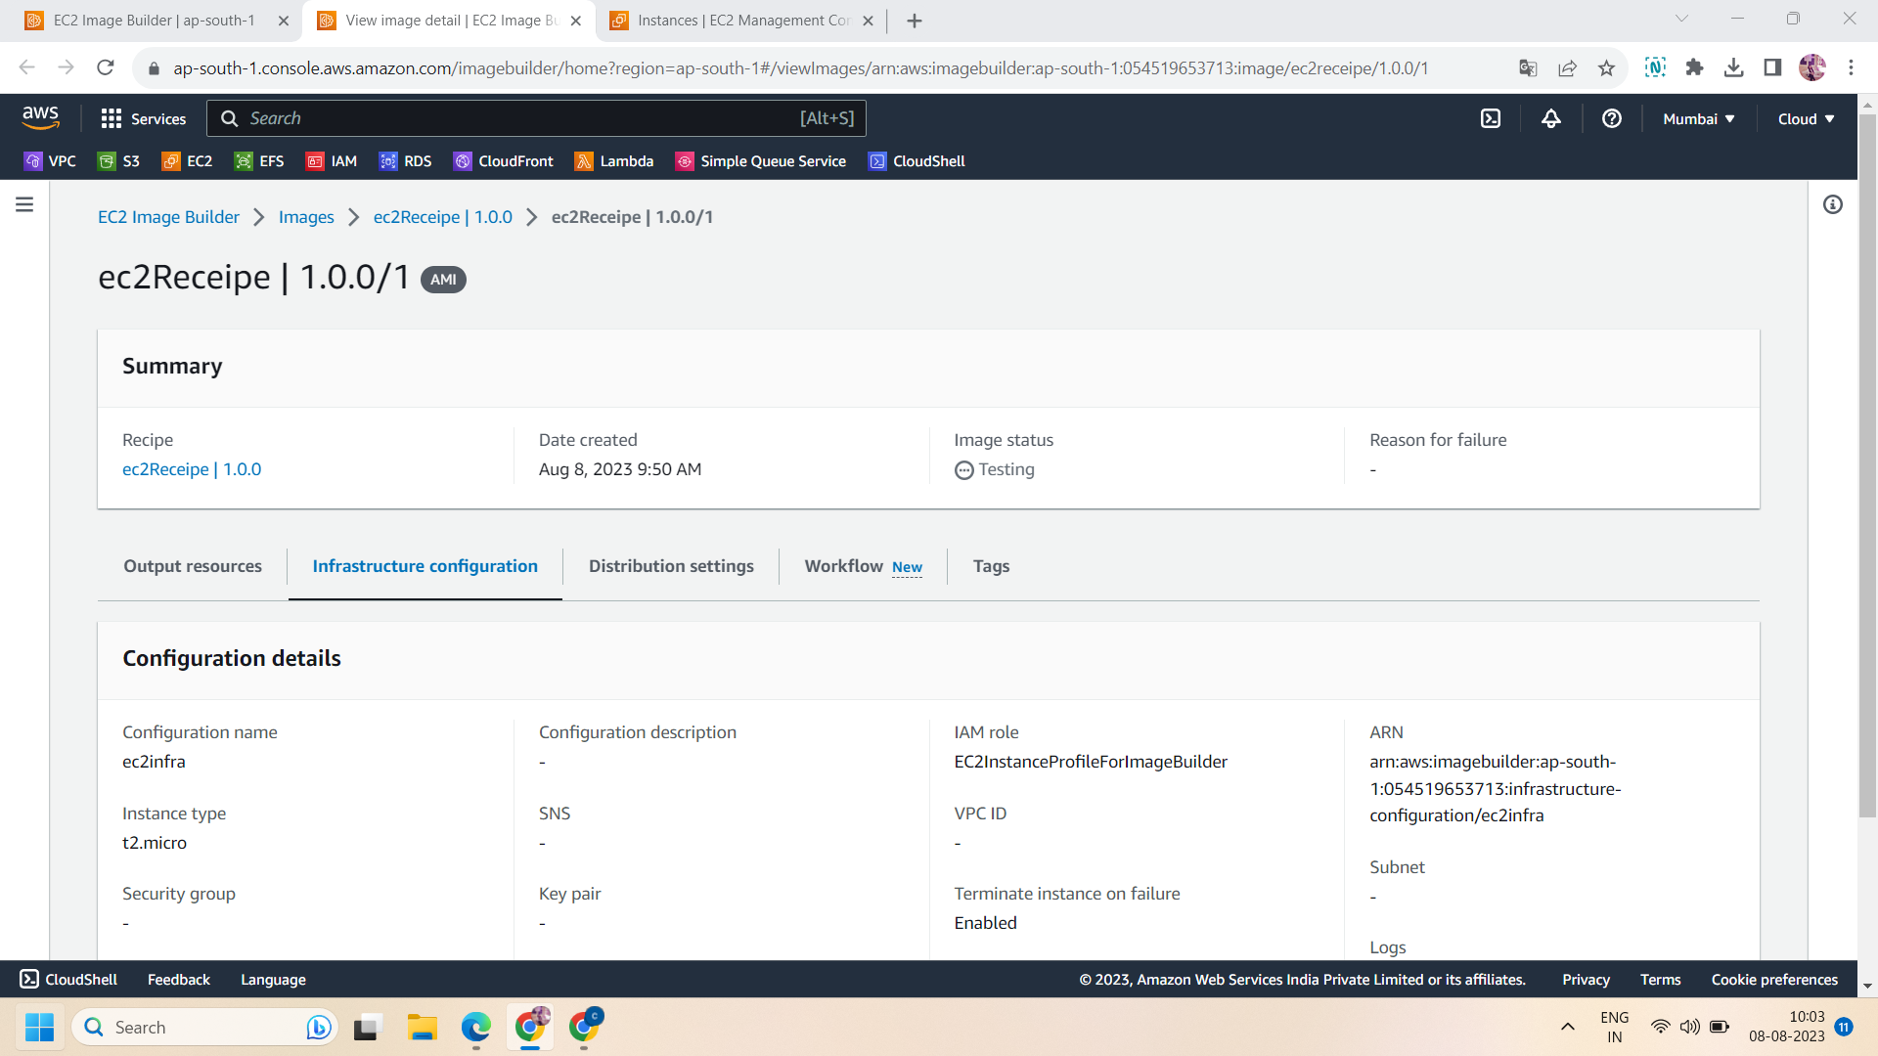

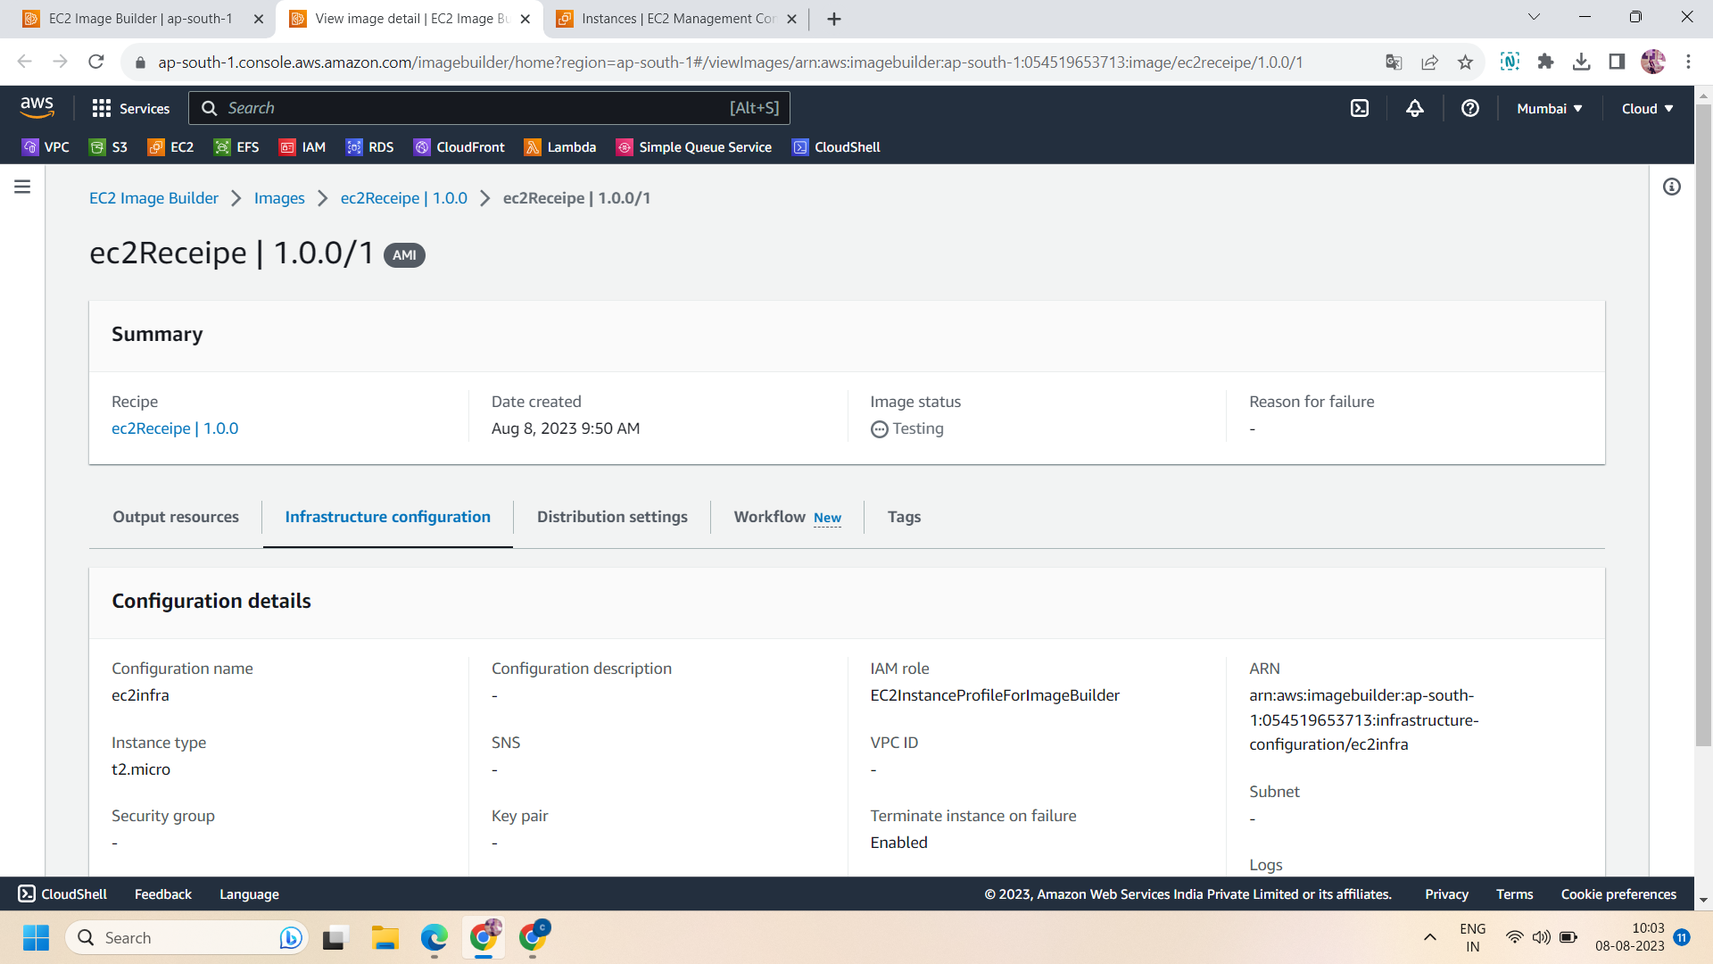

Step 12 : now after sometime status will change to distributing ,now the second instance will also be shut down.

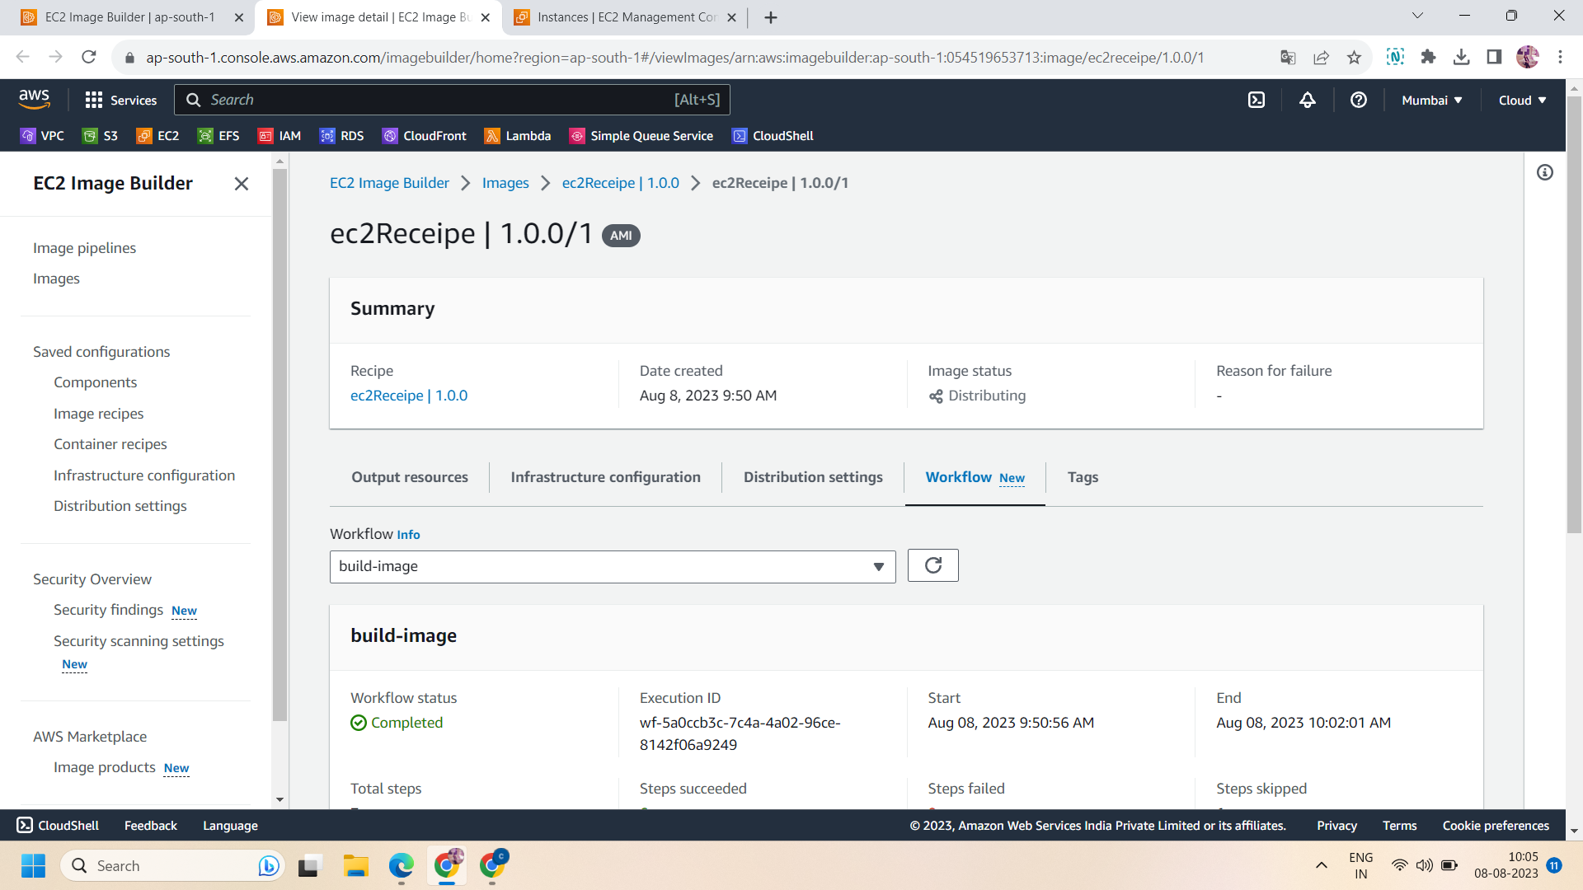

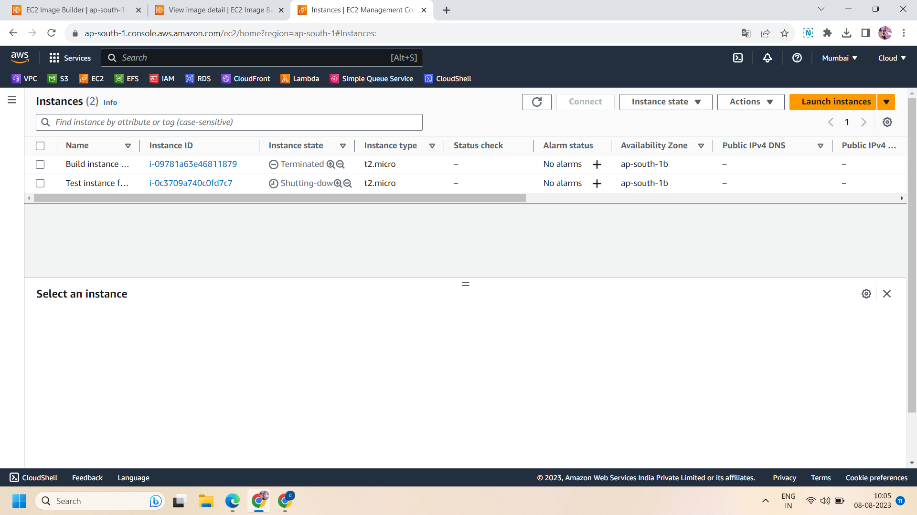

Step 13: then image takes around 30 minutes to change its status to available ,when status changes to available .both the instances will be terminated.

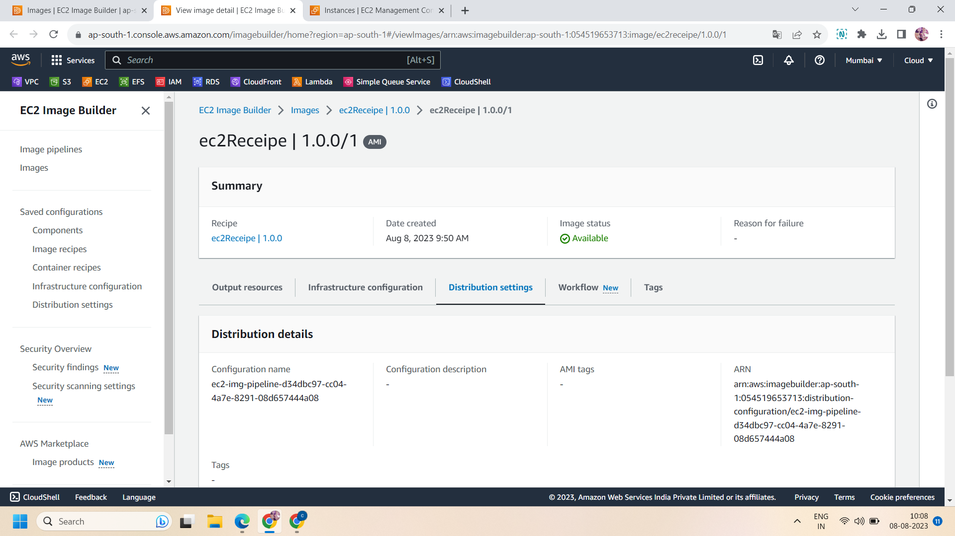

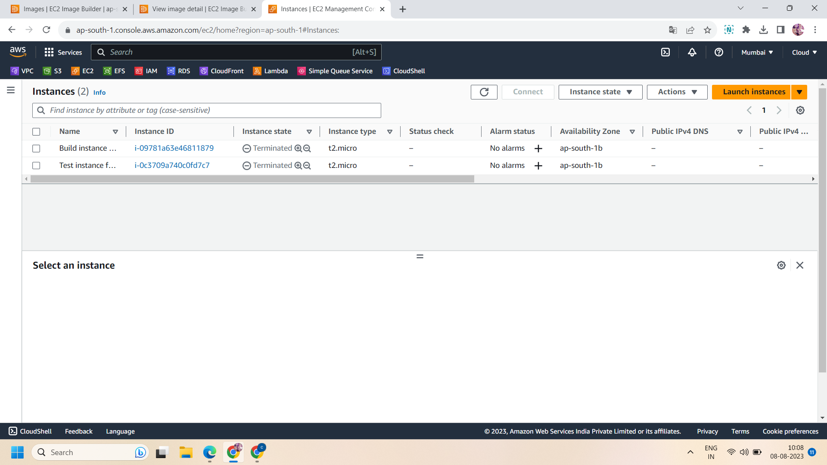

Step 14:Your images will be ready .Now, create a new instance using the image created during ec2 image builder and proceed with no key pair.here we create the instance “Test for AMI” .

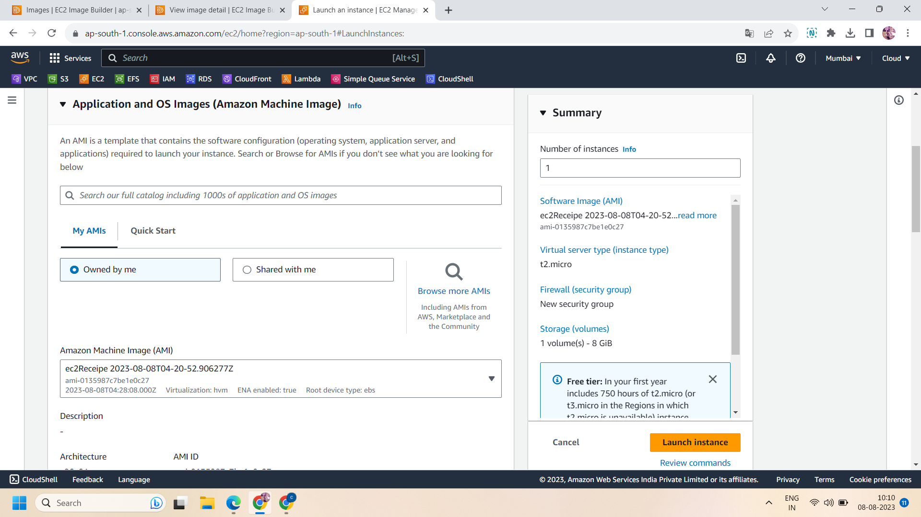

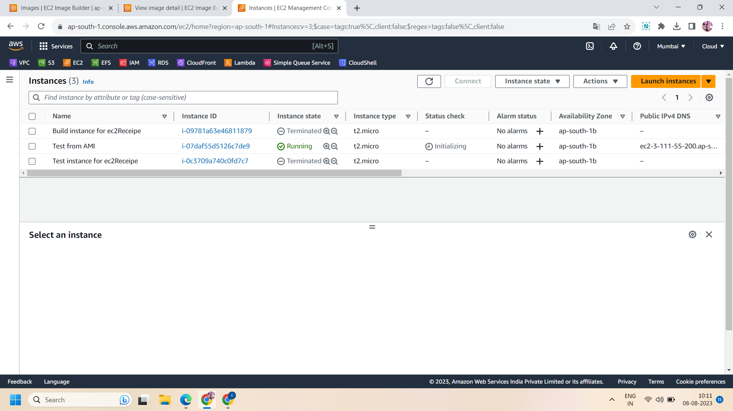

Step 15 : after creating the instance ,connect the instance using ec2 instance connect after changing the username from admin to ec2-user.

Step 16 : now check the version of aws and java .java was installed during pipeline creation (i.e.,amazon-corretto-11-headless)

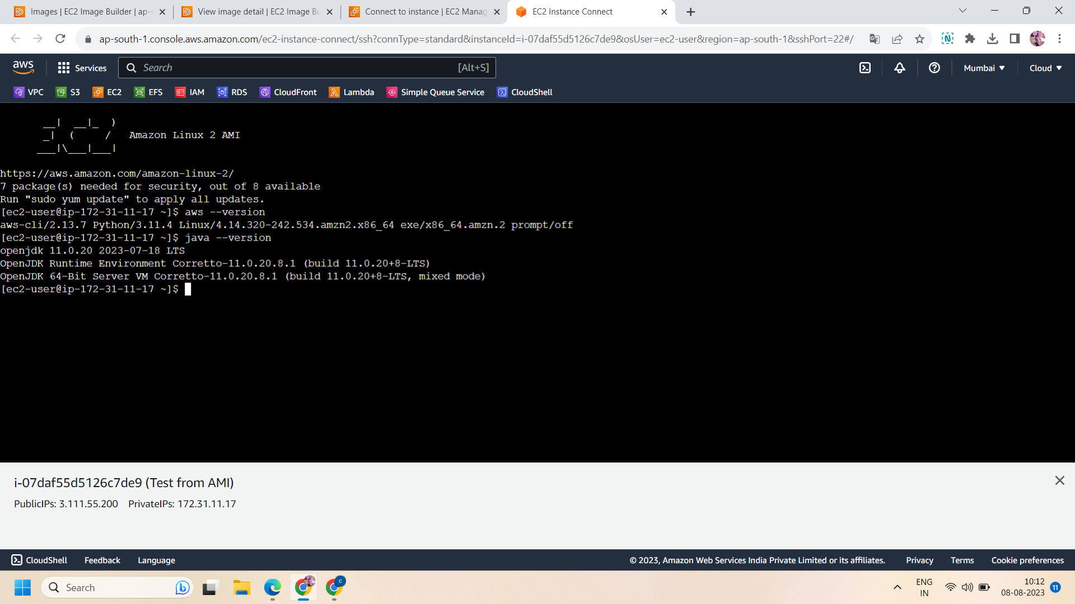

Successfully done!!